GDD Personal Project - Racing Game & Gameplay

**Rodolfo Fava**

**160204 - Y4 Programmer**

Change Log

|  |  |  |
| --- | --- | --- |
| Date | Version | Description |
| 13/02/2020 | 1.0 | Created the document |
| 09/06/2020 | 2.0 | Downscoping the project, scrapped Machine Learning and other secondary features. |
|  |  |  |

# ***Objective***: To create an engaging, elaborate anti-gravity racing game AI and a range of gameplay features. This will help me hone my skills and make me ready to work in a professional environment with a team. I will make use of my experience in Drivinity and my internship at Mechamania to create an innovative AI algorithm that will give the sense of an intelligent entity that is able to compete with the player.

# ***Game Mechanics:*** Basic racing game mechanics*(High Priority)*

* *Win-Lose conditions:* 
  + After a number of laps, the vehicle that is ahead of the others wins the game.
  + Movement:
    - Accelerating
    - Braking
    - Steering
    - Boosting
  + Power-ups:
    - Homing Missile (Targets next vehicle ahead)
    - Banana Peel (Vehicles that go over it spin out of control for a few seconds)

***Add-ons***

(*Low Priority*) - Game Juice, player XP.

* *Power-ups (NPCs that shoot missiles, projecting the target's position)\**
* *Boost Pads*
* *Sound Effects*
* *Soundtrack*
* *HUD that displays enemies and areas of interests* .* Also, vehicle stats like position and best laps would be interesting.

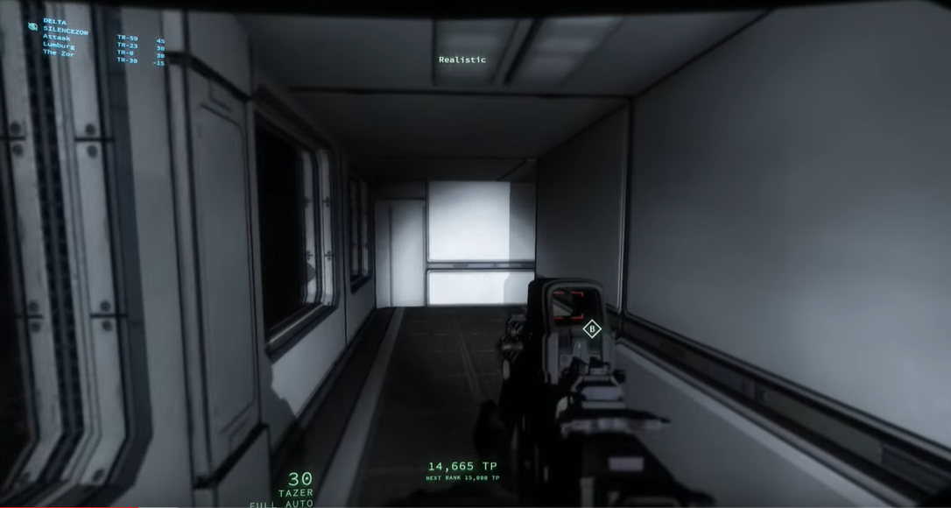

# ***AI goals for Q3***

## Path-Following *(High Priority)*

*Vehicle can go around the track by pursuing waypoints in a spline: 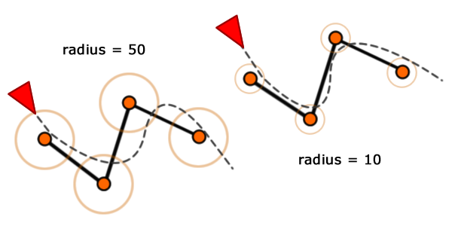*

[*Source*](https://gamedevelopment.tutsplus.com/tutorials/understanding-steering-behaviors-path-following--gamedev-8769)*:*

## Context Steering with Racing Lanes

(Medium Priority)

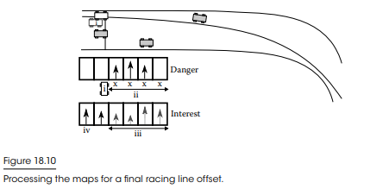

[*Source*](http://www.gameaipro.com/GameAIPro2/GameAIPro2_Chapter18_Context_Steering_Behavior-Driven_Steering_at_the_Macro_Scale.pdf)*:*

Tools & Resources

* **Engine**: UE4. C++ is generally better for the game development industry and Unreal is also seen as more professional.
* **Tracks:** After a meeting with Bojan, I decided to load track obj models from older games (e.g. Wipeout 1995) in order to optimize my development process, so I can focus only on the AI and Gameplay. I had also considered using Samira’s 3D track tool, but for now I will keep it simple. Could be an interesting test for the future.

# Reference Titles

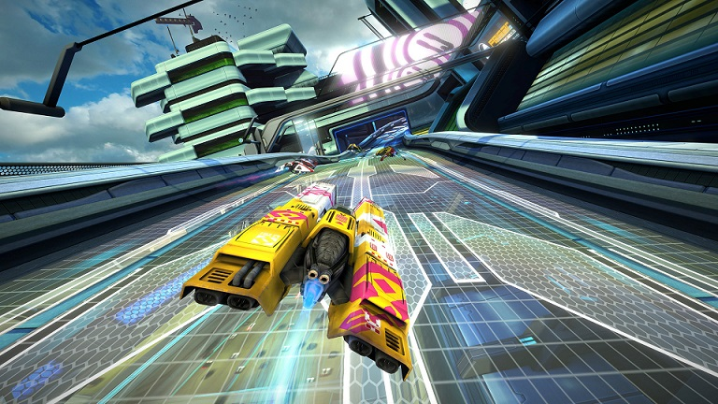

**Wipeout Omega (PS4 - 2017)**

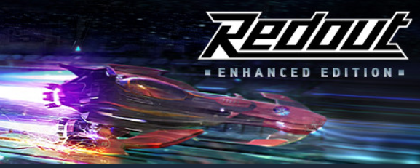

**Redout (PC - 2016)**

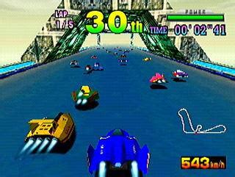

**F-Zero X (Nintendo 64 - 1998)**

What I like about this title is the arcadey feel to it. Quick maneuvers, bumping to the enemy, sending them flying away, recharging Energy levels to boost, all of that sounds like great fun. I want to bring this style of racing into a modern anti-grav racing game, combined with modern graphics, realistic controls and physics from wipeout and redout.